Predbat in Node.js + SQL — Architecture & Slot Model
19 October 2026

Essence
Predbat is a loop that predicts the next 48 hours of a home’s energy, simulates the battery under candidate plans, keeps the cheapest plan, and writes only the next slot’s action to the inverter. Everything else in this document — tables, services, slots — exists to feed or record that loop.
The four verbs of the system:
- Predict — house load from history, solar from a forecast (PV50 central, PV10 pessimistic), import/export prices from the tariff.
- Simulate — step the battery forward in 5-minute increments for a given plan and return a cost (the metric).
- Optimise — search over charge and export windows to minimise that metric, within the user’s limits (reserve, best SoC keep, inverter rates).
- Execute — translate the current slot of the best plan into inverter controls (charge window, target SoC, export window, freeze, reserve). Then repeat every 5 minutes.
The plan is disposable: it is recomputed every cycle from fresh data. Only telemetry and the commands actually sent are facts. This is the single most important principle to keep in the Node.js port.
One system, best of both. The new system is not a port of either version. It keeps the open-source engine’s transparency, tunability and local control, and adds the cloud version’s zero-install onboarding, managed credentials and fleet scale. One codebase runs in three deployment modes — edge, cloud and hybrid — chosen per site by a single column, site.deployment_mode.
Sources: What does Predbat do?, apps.yaml settings, Predbat README, cloud release-mode issue #4481.

Best of both: what the new system keeps
Each capability below is taken from whichever version does it best, and lands in one place in the new design.
Capability | Strongest in | Where it lives in the new system
Transparent, deterministic planner (5-min simulation, 30-min slots, PV10 weighting) | Open source | planner/ package with no I/O; same code in every mode
Local control that keeps working when the internet is down | Open source | Edge agent talks MQTT / Modbus / Home Assistant directly
Deep tunables (best SoC keep, metric weights, freeze modes, manual overrides) | Open source | site_setting rows with safe defaults; advanced settings hidden until enabled
Visible plan, read-only mode, full history for debugging | Open source | Append-only plan_run + plan_slot, event_log
Zero-install onboarding with automatic inverter discovery | Cloud | Vendor adapters with auto-configuration; no YAML
Managed secrets and OAuth token refresh | Cloud | credential.secret_ref pointing to a vault, refreshed by a worker
Multi-site scale and fleet monitoring | Cloud | tenant_id scoping, SKIP LOCKED scheduler, worker pools, alerts on event_log
Safe hand-back when a site leaves | Cloud | One-shot release command: Demand mode, windows cleared, read-back confirmed

Three deployment modes, one codebase
Mode | Planner runs | Executor runs | Database | When to use
Edge | On site (Pi, HA box) | On site | SQLite | Privacy-first, no subscription, local-only inverters
Cloud | Hosted | Hosted, via vendor cloud API | PostgreSQL | No hardware on site, vendor has a good cloud API
Hybrid (default) | Hosted | On site (edge agent) | PostgreSQL + SQLite cache | Best of both: cloud brains, local hands
Hybrid is the recommended default. The cloud does the heavy optimisation, fleet monitoring and onboarding; a small edge agent receives the next 24 h of plan_slot rows, executes them over local protocols, and streams telemetry back. If the link drops, the agent keeps following its cached plan while that plan is under 2 h old, then falls back to Demand — local resilience without giving up the safety rule that stale plans never run indefinitely.
Schema additions for this:
ALTER TABLE site ADD COLUMN deployment_mode text NOT NULL DEFAULT 'hybrid'
CHECK (deployment_mode IN ('edge','cloud','hybrid'));
CREATE TABLE edge_agent (
id uuid PRIMARY KEY DEFAULT gen_random_uuid(),
site_id uuid NOT NULL REFERENCES site(id),
last_seen_at timestamptz,
plan_run_synced bigint REFERENCES plan_run(id), -- latest plan the agent holds
version text
);

Slots: the time model
Time is a grid of 5-minute steps grouped into 30-minute slots; plans are made of slots, simulation runs on steps. Every table that holds a time series keys on the slot or step start, in UTC, aligned to the boundary.
Unit | Size | Used for | Rule
Step | 5 min | Simulation, telemetry, load history | Everything is a multiple of 5 minutes
Slot (plan interval) | 30 min (configurable) | Prices, plan rows, charge decisions | Aligned to :00 / :30 to match how tariffs price energy
Window | N contiguous slots | Inverter programming | Adjacent slots with the same action are merged into one window
Horizon | 48 h (forecast_hours) | Prediction length | At least ~24 h past the first charge slot is planned
Slot index. Use minute_of_horizon = (t - plan_start) / 60, step = minute / 5, slot = minute / 30. A 48 h horizon is 576 steps and 96 slots, so every series is a fixed-length array in memory and a set of rows keyed by slot_start in SQL.
Asymmetry worth keeping. Charge slots are whole multiples of the plan interval and aligned to its boundaries. Export slots can be any multiple of 5 minutes but always end on a plan-interval boundary — so an export window may start at 17:20 and end at 18:00. Model this as slot_start + start_offset_min on the export side.
Slot action states. Each plan slot carries exactly one action; the executor derives the inverter mode from it.
Action | Battery behaviour | Key parameter
demand | Covers load from battery/solar, excess solar charges battery (Eco) | none
charge | Force charge from grid up to target | target_soc_pct
freeze_charge | Hold SoC; grid covers load; surplus solar may still charge | target = current SoC
export | Force discharge to grid down to a floor | export_limit_pct
freeze_export | Demand with charging disabled: solar surplus exported, SoC held | none
Two derived states appear only at execution time: hold charging (target ≤ current SoC) and hold exporting (floor reached). Store them in the command log, not the plan.
Encoding convention (from Predbat). Internally a charge limit of 0 means “no charge” and an export limit of 100 means “no export”; these are the sentinel values the optimiser uses when it switches a slot off. Keeping the same sentinels makes the optimiser code simpler — every slot always has both numbers.
Sources: What does Predbat do? — Slot terminology, PR #4491 slot pruning.

Architecture
Five Node.js services share one SQL database and never call each other directly; the database is the contract. That keeps each service small, restartable and testable on its own.
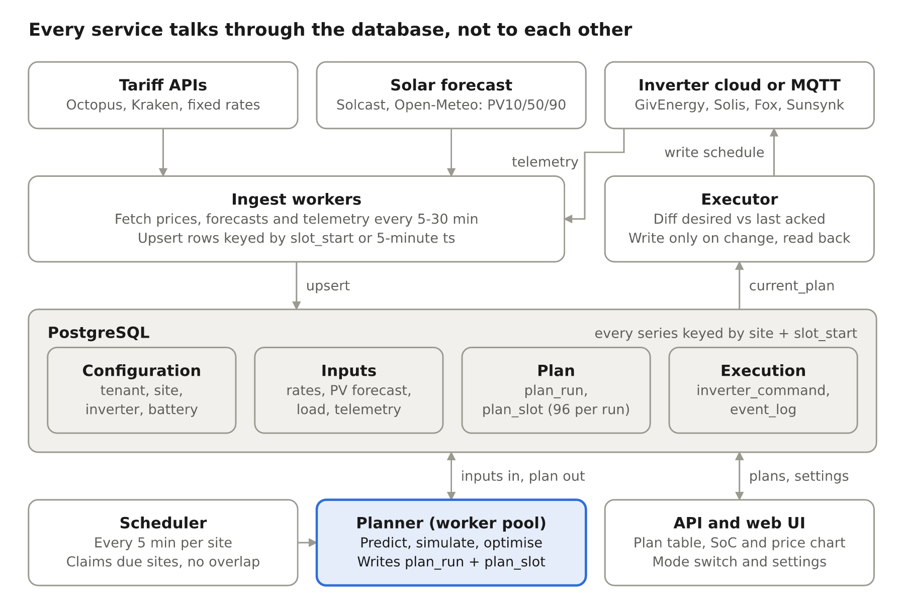
Node.js + SQL architecture · 5 services around one database
The scheduler claims a due site (SELECT … FOR UPDATE SKIP LOCKED on site.next_run_at), runs the planner in a worker thread, then triggers the executor for that site. Ingest runs on its own timers so a slow tariff API never delays a plan.
Principles
- One pure engine. planner/ has no database or HTTP imports: inputs in, slots out. Same code for self-hosted and cloud.
- Adapters at the edge. Each tariff, forecast and inverter vendor is a small module implementing fetch() or apply(desiredState). Adding a vendor touches nothing else.
- Append-only plans. Never update a plan; write a new plan_run. History is free debugging.
- One codebase, three modes. Edge runs all five services in one process on SQLite; cloud runs them as separate processes on PostgreSQL with tenant_id scoping every query; hybrid puts planner, ingest and API in the cloud and the executor on a local edge agent.
- Fail safe, not stuck. Any missing or stale input degrades to Demand mode, never to the last plan.
Suggested layout: src/{scheduler,ingest,planner,executor,api}/, src/adapters/{tariff,pv,inverter}/, src/lib/slots.js, migrations/.

Database schema
Fourteen tables in four groups — configuration, inputs, plan, execution — with every time series keyed by (site_id, slot_start) or (site_id, ts). PostgreSQL is assumed (timestamptz, jsonb); the same shapes work on MySQL or SQLite with minor type changes.
Group | Tables | Written by | Changes
Configuration | tenant, site, inverter, battery, site_setting, credential | User / admin | Rarely
Inputs | tariff_rate, pv_forecast, load_history, telemetry | Ingest workers | Every 5–30 min
Plan | plan_run, plan_slot | Planner | Every 5 min, append-only
Execution | inverter_command, event_log | Executor | On change

Configuration
CREATE TABLE tenant (
id uuid PRIMARY KEY DEFAULT gen_random_uuid(),
name text NOT NULL,
plan_tier text NOT NULL DEFAULT 'self_hosted', -- 'self_hosted' | 'cloud'
created_at timestamptz NOT NULL DEFAULT now()
);
CREATE TABLE site (
id uuid PRIMARY KEY DEFAULT gen_random_uuid(),
tenant_id uuid NOT NULL REFERENCES tenant(id),
name text NOT NULL,
timezone text NOT NULL DEFAULT 'Europe/London',
mode text NOT NULL DEFAULT 'monitor',
-- 'monitor' | 'control_charge' | 'control_charge_export' | 'read_only'
plan_interval_min int NOT NULL DEFAULT 30 CHECK (plan_interval_min % 5 = 0),
forecast_hours int NOT NULL DEFAULT 48,
export_limit_w int, -- G98/G99 site cap
is_active boolean NOT NULL DEFAULT true,
next_run_at timestamptz -- scheduler cursor
);
CREATE TABLE inverter (
id uuid PRIMARY KEY DEFAULT gen_random_uuid(),
site_id uuid NOT NULL REFERENCES site(id),
vendor text NOT NULL, -- 'givenergy_cloud','solis_cloud','fox','mqtt',...
serial text,
is_hybrid boolean NOT NULL DEFAULT true,
ac_limit_w int NOT NULL, -- inverter_limit
charge_limit_w int, -- inverter_limit_charge
discharge_limit_w int, -- inverter_limit_discharge
export_rate_limit_w int, -- inverter_limit_export
supports_freeze boolean NOT NULL DEFAULT true,
supports_export boolean NOT NULL DEFAULT true,
credential_id uuid
);
CREATE TABLE battery (
id uuid PRIMARY KEY DEFAULT gen_random_uuid(),
inverter_id uuid NOT NULL REFERENCES inverter(id),
soc_max_kwh numeric(6,2) NOT NULL,
reserve_pct numeric(5,2) NOT NULL DEFAULT 4,
rate_max_w int NOT NULL DEFAULT 2600,
loss_charge numeric(4,3) NOT NULL DEFAULT 0.96, -- efficiency in
loss_discharge numeric(4,3) NOT NULL DEFAULT 0.96, -- efficiency out
charge_curve jsonb -- {soc_pct: rate_factor}, optional
);
-- Tunables Predbat exposes as input_number / switch entities
CREATE TABLE site_setting (
site_id uuid NOT NULL REFERENCES site(id),
key text NOT NULL, -- 'best_soc_keep','pv_metric10_weight','combine_charge_slots',...
value jsonb NOT NULL,
PRIMARY KEY (site_id, key)
);
CREATE TABLE credential (
id uuid PRIMARY KEY DEFAULT gen_random_uuid(),
tenant_id uuid NOT NULL REFERENCES tenant(id),
provider text NOT NULL, -- 'octopus','solcast','givenergy',...
secret_ref text NOT NULL, -- pointer to a vault/KMS entry, never the secret
expires_at timestamptz
);

Inputs (one row per slot or step)
CREATE TABLE tariff_rate (
site_id uuid NOT NULL REFERENCES site(id),
direction text NOT NULL CHECK (direction IN ('import','export')),
slot_start timestamptz NOT NULL,
rate_p_kwh numeric(8,4) NOT NULL,
source text NOT NULL, -- 'octopus_api','fixed','override','iog_dispatch'
fetched_at timestamptz NOT NULL DEFAULT now(),
PRIMARY KEY (site_id, direction, slot_start)
);
CREATE TABLE pv_forecast (
site_id uuid NOT NULL REFERENCES site(id),
slot_start timestamptz NOT NULL,
pv50_kwh numeric(8,4) NOT NULL,
pv10_kwh numeric(8,4) NOT NULL,
pv90_kwh numeric(8,4) NOT NULL,
source text NOT NULL, -- 'solcast','forecast_solar','open_meteo'
fetched_at timestamptz NOT NULL,
PRIMARY KEY (site_id, slot_start)
);
CREATE TABLE load_history ( -- 5-minute buckets, the input to load prediction
site_id uuid NOT NULL REFERENCES site(id),
ts timestamptz NOT NULL, -- aligned to :00, :05, :10 ...
load_kwh numeric(8,4) NOT NULL,
car_kwh numeric(8,4) NOT NULL DEFAULT 0, -- filtered out of load if configured
is_holiday boolean NOT NULL DEFAULT false,
PRIMARY KEY (site_id, ts)
);
CREATE TABLE telemetry ( -- latest readings, also 5-minute
inverter_id uuid NOT NULL REFERENCES inverter(id),
ts timestamptz NOT NULL,
soc_kwh numeric(6,2),
battery_w int, -- + discharge, - charge
grid_w int, -- + export, - import
pv_w int,
load_w int,
import_kwh_today numeric(8,3),
export_kwh_today numeric(8,3),
PRIMARY KEY (inverter_id, ts)
);

Plan (append-only, one run per cycle)
CREATE TABLE plan_run (
id bigserial PRIMARY KEY,
site_id uuid NOT NULL REFERENCES site(id),
created_at timestamptz NOT NULL DEFAULT now(),
plan_start timestamptz NOT NULL, -- slot-aligned 'now'
soc_start_kwh numeric(6,2) NOT NULL,
metric_base numeric(10,2), -- cost if we do nothing new
metric_best numeric(10,2), -- cost of chosen plan (incl. battery value)
metric_best10 numeric(10,2), -- chosen plan under PV10 / pessimistic load
duration_ms int,
status text NOT NULL DEFAULT 'ok', -- 'ok' | 'stale_inputs' | 'error'
inputs_hash text -- detect no-change runs
);
CREATE TABLE plan_slot (
plan_run_id bigint NOT NULL REFERENCES plan_run(id) ON DELETE CASCADE,
slot_start timestamptz NOT NULL,
action text NOT NULL
CHECK (action IN ('demand','charge','freeze_charge','export','freeze_export')),
start_offset_min int NOT NULL DEFAULT 0, -- export may start mid-slot
charge_limit_pct numeric(5,2) NOT NULL DEFAULT 0, -- 0 = no charge
export_limit_pct numeric(5,2) NOT NULL DEFAULT 100, -- 100 = no export
rate_w int, -- requested power, null = max
-- predicted outcome at end of slot (for the UI and for later accuracy checks)
soc_end_kwh numeric(6,2) NOT NULL,
import_kwh numeric(8,4) NOT NULL,
export_kwh numeric(8,4) NOT NULL,
pv_kwh numeric(8,4) NOT NULL,
load_kwh numeric(8,4) NOT NULL,
cost_p numeric(10,4) NOT NULL,
PRIMARY KEY (plan_run_id, slot_start)
);
-- The plan the executor follows = the latest ok run per site
CREATE VIEW current_plan AS
SELECT DISTINCT ON (site_id) *
FROM plan_run WHERE status = 'ok'
ORDER BY site_id, created_at DESC;

Execution
CREATE TABLE inverter_command (
id bigserial PRIMARY KEY,
inverter_id uuid NOT NULL REFERENCES inverter(id),
plan_run_id bigint REFERENCES plan_run(id),
created_at timestamptz NOT NULL DEFAULT now(),
desired jsonb NOT NULL, -- {charge_window:{start,end}, target_soc, export_window, reserve, freeze}
status text NOT NULL DEFAULT 'pending', -- 'pending'|'sent'|'acked'|'failed'|'skipped'
attempts int NOT NULL DEFAULT 0,
error text,
acked_at timestamptz
);
CREATE TABLE event_log (
id bigserial PRIMARY KEY,
site_id uuid NOT NULL REFERENCES site(id),
ts timestamptz NOT NULL DEFAULT now(),
level text NOT NULL, -- 'info'|'warn'|'error'
kind text NOT NULL, -- 'status_change','ingest_fail','calibration',...
detail jsonb
);
Retention. plan_run grows by 288 rows a day per site and plan_slot by ~27,600. Keep the full detail for 7 days, then keep only the slot that was actually executed from each run (or partition by day and drop). load_history needs 30 days at most; telemetry can be downsampled after 30 days.

Process flow
One cycle per site every 5 minutes: gather, predict, optimise, save, then write only what changed. Stale inputs short-circuit straight to a Demand-only plan.
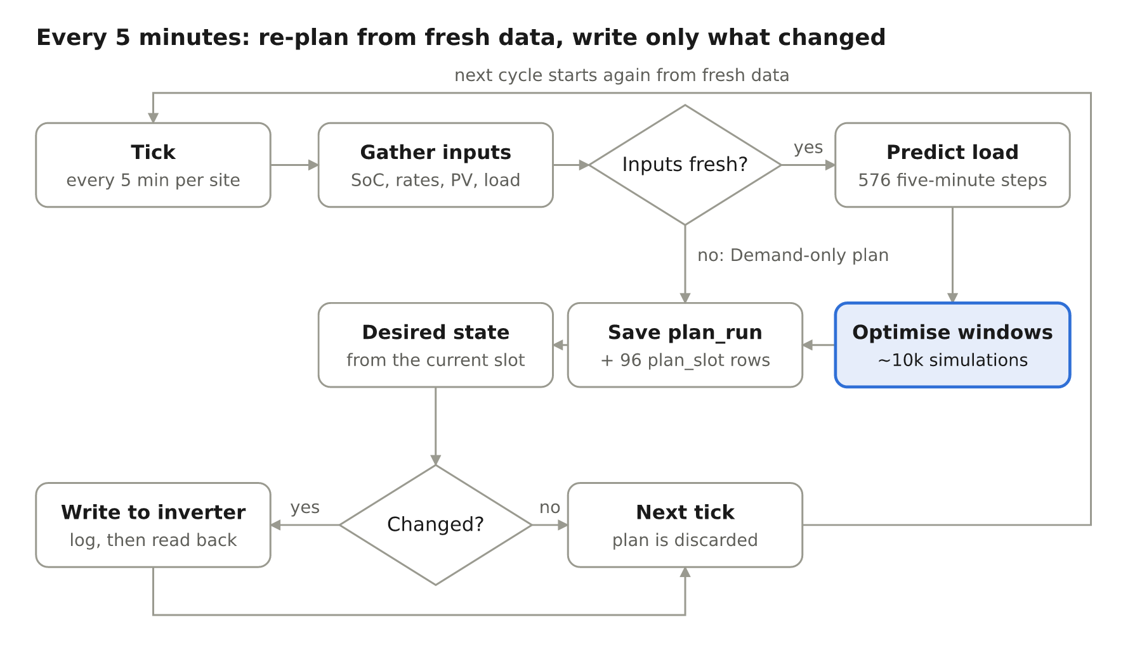
The 5-minute planning and execution cycle
// scheduler/cycle.js — one site, one cycle
async function runCycle(db, siteId) {
const inputs = await loadInputs(db, siteId); // rates, pv, load_history, latest telemetry
const fresh = isFresh(inputs, { maxAgeMin: 60 });
const slots = fresh
? await planner.run(inputs, inputs.settings) // worker_threads pool
: demandOnlyPlan(inputs);
const run = await savePlan(db, siteId, inputs, slots, fresh ? 'ok' : 'stale_inputs');
if (inputs.site.mode === 'monitor' || inputs.site.mode === 'read_only') return run;
for (const inv of inputs.inverters) {
const desired = desiredState(currentWindow(slots, inputs.now), inv, inputs.socPct[inv.id]);
const last = await lastAcked(db, inv.id);
if (!sameState(desired, last)) await enqueueCommand(db, inv.id, run.id, desired);
}
await db.query('UPDATE site SET next_run_at = $2 WHERE id = $1', [siteId, nextTick(inputs.now)]);
}
The command queue is drained by the vendor adapter, which retries on failure and marks rows acked after read-back. Re-planning every 5 minutes is what makes the system self-correcting: a wrong load guess at 07:00 is fixed by the 07:05 plan.

Planning logic
The planner is a pure function: plan(inputs, settings) → slots[]. It does no I/O, so it can be unit-tested with fixtures and run in a worker thread. It has three parts: a load predictor, a simulator, and an optimiser that calls the simulator thousands of times.

1. Load prediction
Build a 576-step array of expected load from load_history. Predbat’s default (days_previous_auto) takes a weighted average per 5-minute time-of-day over up to 30 days:
- Weekday weight: 1.0 same day of week; 0.7 both weekdays or both weekend; 0.5 weekday vs weekend.
- Age weight: 0.9 for yesterday, minus 0.03 per day, floor 0.1.
- Only samples whose holiday state matches the predicted day are used; zero buckets (gaps) are ignored.
Car charging energy is subtracted from history when configured, so a one-off EV charge doesn’t inflate tomorrow’s load.

2. Simulator
Given a plan, step the battery forward and return the metric. This is the hot loop — keep it allocation-free.
// All arrays are length = horizonSteps (576 for 48h). Energy in kWh per 5-min step.
function simulate(plan, inp, cfg, scenario = 'pv50') {
let soc = inp.socStartKwh, cost = 0;
const pv = inp[scenario]; // pv50 | pv10 array
const maxStep = cfg.rateMaxW / 1000 / 12; // kWh per 5 min
const reserve = cfg.socMaxKwh * cfg.reservePct / 100;
for (let s = 0; s < inp.steps; s++) {
const slot = plan[Math.floor(s / cfg.stepsPerSlot)];
const load = inp.load[s], solar = pv[s];
let battery = 0; // + discharge, - charge (kWh, battery side)
switch (slot.action) {
case 'charge': {
const target = cfg.socMaxKwh * slot.chargeLimitPct / 100;
battery = soc < target ? -Math.min(maxStep, (target - soc) / cfg.lossIn) : 0;
break;
}
case 'export': {
const floor = Math.max(reserve, cfg.socMaxKwh * slot.exportLimitPct / 100);
if (s % cfg.stepsPerSlot >= slot.startOffsetMin / 5)
battery = soc > floor ? Math.min(maxStep, soc - floor) : 0;
else battery = demandStep(load, solar, soc, reserve, maxStep, cfg);
break;
}
case 'freeze_charge': battery = Math.min(0, -(solar - load)); // only absorb surplus
battery = Math.max(battery, -maxStep); break;
case 'freeze_export': battery = Math.max(0, demandStep(load, solar, soc, reserve, maxStep, cfg)); break;
default: battery = demandStep(load, solar, soc, reserve, maxStep, cfg);
}
soc -= battery > 0 ? battery : battery * cfg.lossIn; // apply efficiency on charge
const ac = solar + (battery > 0 ? battery * cfg.lossOut : battery) - load;
const exportKwh = Math.min(Math.max(ac, 0), cfg.exportLimitKwhStep);
const importKwh = Math.max(-ac, 0);
cost += importKwh * inp.importRate[s] - exportKwh * inp.exportRate[s];
}
// Value energy left in the battery so the plan doesn't dump it for free
const keepPenalty = Math.max(0, cfg.bestSocKeepKwh - soc) * inp.avgImportRate;
return cost - soc * cfg.batteryValuePerKwh + keepPenalty;
}
demandStep covers load from the battery (down to reserve) and charges from surplus solar, both capped at maxStep. Clipping against ac_limit_w and export_limit_w is applied when computing ac.

3. The metric
Predbat scores a plan by cost, not by SoC. A simple, faithful version:
metric = cost_pv50 + w10 × (cost_pv10 − cost_pv50) − value(SoC_end) + penalty(SoC < keep)
- cost = import × import rate − export × export rate, summed over the horizon.
- w10 (pv_metric10_weight) pulls the plan towards the pessimistic solar case, so it doesn’t bet the house on a sunny day.
- value(SoC_end) stops the optimiser emptying the battery at the horizon edge.
- A small per-cycle battery wear cost can be added to discourage marginal cycling.

4. Optimiser
No solver library — Predbat uses ordered, greedy search over candidate windows, and that is enough. Passes:
- Find candidate windows. Low-rate slots (import rate below a threshold computed from future rates) become charge candidates; high-rate slots (export above threshold) become export candidates. Adjacent slots at the same price merge into a window.
- Charge levels. For each charge window, cheapest first, try target SoC levels (e.g. 0, 10, …, 100 %) and keep the one with the lowest metric. Re-evaluate earlier windows once later ones are set.
- Export levels. For each export window, highest price first, try floors (100 = off down to reserve) and start offsets, keep the best.
- Freeze pass. Try swapping charge → freeze_charge and demand → freeze_export where it lowers the metric.
- Coarse then fine. Search a reduced set of window lengths first, then only lengths near the best (Predbat’s enable_coarse_fine_levels).
- Prune dead slots. Remove each active slot in turn and re-simulate in PV50 only; if the metric doesn’t worsen, drop it. This keeps the inverter quiet.
- Clip limits. Narrow each requested target to what the window can actually achieve, so adjacent windows merge.
Budget: ~100 slots × ~10 levels × a few passes ≈ 5,000–20,000 simulations per cycle. At ~576 steps each that is ~10 million step evaluations — a few hundred ms in plain JS. Run it in a worker_threads pool so the event loop stays free.
Sources: days_previous_auto weighting, What does Predbat do? — low/high-rate slots, PV10, PR #4491 model-based pruning.

Execution & safety
The executor reads only the current slot (plus the end of its window) from current_plan, computes a desired state, diffs it against the last acked command, and writes only if they differ. It never writes the whole 48 h plan to the inverter.
Desired state per inverter
function desiredState(window, inv, socNowPct) {
switch (window.action) {
case 'charge':
return { mode: 'charge', chargeWindow: [window.start, window.end],
targetSocPct: window.chargeLimitPct, chargeRateW: window.rateW ?? inv.chargeLimitW,
exportWindow: null, reservePct: inv.reservePct };
case 'freeze_charge':
return { mode: 'charge', chargeWindow: [window.start, window.end],
targetSocPct: socNowPct, reservePct: socNowPct }; // hold
case 'export':
return { mode: 'export', exportWindow: [window.start, window.end],
exportFloorPct: window.exportLimitPct, rateW: inv.exportRateLimitW,
chargeWindow: null, reservePct: inv.reservePct };
case 'freeze_export':
return { mode: 'demand', chargeRateW: 0, exportWindow: null }; // no charging
default:
return { mode: 'demand', chargeWindow: null, exportWindow: null,
reservePct: inv.reservePct };
}
}
Each vendor adapter maps this neutral state onto its own controls (time windows, target SoC registers, work modes, rate in W or A). Freeze modes differ the most by vendor: some have a pause mode, some need a zero charge rate, some can’t do freeze export at all — record that in inverter.supports_freeze / supports_export, and the optimiser must not plan actions the inverter can’t deliver.
Safety rules
- Idempotent writes. Diff before sending; store the payload hash. Re-sending the same schedule every 5 minutes wears cloud API quotas (some vendors allow very few writes per day).
- Verify, don’t trust. After a write, read back the inverter’s schedule on the next cycle; mark the command acked only when it matches.
- Stale inputs → demand. If prices, forecast or SoC are older than a threshold, mark the run stale_inputs and send Demand (the inverter’s safe default), never an old charge/export window.
- Modes gate writes. monitor and read_only produce plans but write nothing; control_charge never sends export windows.
- Calibration and external events. If the inverter reports calibration, or a VPP event is active, pause execution and log it.
- Release on teardown (cloud). When a site is deleted or credentials removed, run a one-shot release: reset to Demand, clear windows, confirm read-back. A cloud site must never be left with a schedule armed.
Sources: Freeze export mapping, PR #4616, AlphaESS write limits and export limitations, Release mode, issue #4481.

Compared with EnergieBee core
EnergieBee core (Technext report, 19 Oct 2026) is a working measurement ledger; this Predbat.js + SQL design is a controller. They share the 30-minute slot grid over 5-minute samples, and they differ on almost everything else. The full comparison is in the companion report EnergieBee Core and the Planning Design: Comparison and IoT Framing.
Area | EnergieBee core | Predbat.js + SQL (this document) | Change to make here
Purpose | What happened, priced and proven | What the battery does next | Keep both: ledger feeds planner
Input storage | Append-only, versioned facts with raw_id provenance | tariff_rate, pv_forecast, load_history, telemetry upserted | Replace these four tables with EnergieBee’s fact layer
Tariffs | Shared tariff + versioned rate_interval, agreements, VAT, standing charges | Prices copied per site per slot | Use EnergieBee’s tariff model
Battery parameters | Measured capacity and daily efficiency, ranked by source | Typed-in soc_max_kwh, loss_charge | Read measured values from site_attribute
Data quality | final / provisional / missing, quality bits, daily checks | stale_inputs only | Freshness gate reads EnergieBee’s states
Control path | None | Executor, inverter_command, read-back | Keep — this is what Predbat.js adds
Optimiser | None | Simulator + greedy search | Keep
Tenancy and scale | One home, serial sync (≈ 25 homes per cycle) | tenant_id, parallel workers | Keep; add site_id to facts
Growth | Forecast rows were 59% of DB bytes until stored on change | Plans would add 27,648 plan_slot rows per site per day | Store plans only when they change
The short version: take EnergieBee’s data layer whole, and keep this document’s planner, executor and tenancy on top of it.

Build order and open questions
Build the planner first and against fixtures; hardware comes last. Each step is usable on its own.
- Schema + slot utilities — migrations, alignToSlot(), stepIndex(), timezone/DST tests (a 23 h and 25 h day must still produce correct slot rows).
- Simulator — simulate() with golden tests: flat rate, two-rate overnight tariff, Agile-style half-hourly prices.
- Load predictor — weighted history average; test with gaps and holiday days.
- Optimiser — charge pass only, then export, then freeze, then prune. Compare metric vs a “do nothing” baseline on each test day.
- Ingest — one tariff source (fixed rates or Octopus), one PV source (Solcast or Open-Meteo), one inverter adapter in read-only.
- Executor — desired-state diff, command log, read-back; run in monitor mode for a week before enabling control.
- API + UI — plan table and SoC/price chart from current_plan; mode switch; settings.
- Multi-tenant cloud — tenant isolation, vault-backed credentials, worker pool, release-on-teardown.
Open questions
- Which inverter and tariff should the first adapter target?
- Single-site self-hosted first, or multi-tenant from day one? (The schema supports both; the scheduler differs.)
- Is EV charging and Intelligent Octopus dispatch in scope for v1? Both add slot sources that can change mid-day.
- Licence: Predbat is free for personal use only, all rights reserved — a commercial cloud port should be a clean-room re-implementation of the ideas, not a code translation. Worth confirming with the author before shipping.
Sources: Predbat licence, README.

